**Use Case diagram**

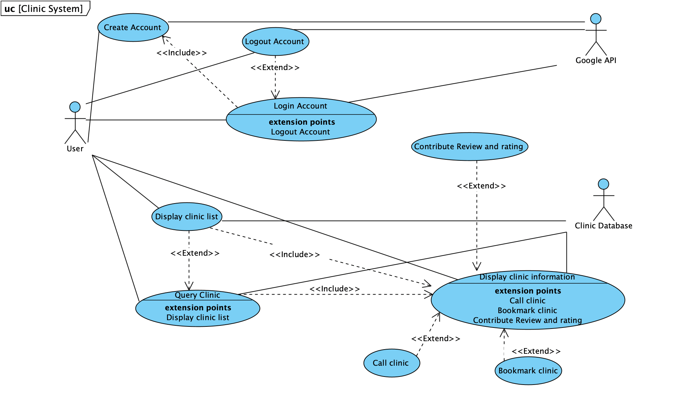

**Use Cases**

**for**

**<ClinicFinder>**

**Version 1.0 approved**

**Prepared by <Derrick>**

**<Dexter>**

**<28/08/2022>**

**Revision History**

| **Name** | **Date** | **Reason For Changes** | **Version** |
| --- | --- | --- | --- |
|  |  | Implementation of mandatory login |  |
|  |  |  |  |

# 

# 

# **Guidance for Use Case Template**

Document each use case using the template shown in the Appendix. This section provides a description of each section in the use case template.

# **1.** **Use Case Identification**

## **1.1.** **Use Case ID**

Give each use case a unique numeric identifier, in hierarchical form: X.Y. Related use cases can be grouped in the hierarchy. Functional requirements can be traced back to a labelled use case.

## **1.2.** **Use Case Name**

State a concise, results-oriented name for the use case. These reflect the tasks the user needs to be able to accomplish using the system. Include an action verb and a noun. Some examples:

· View part number information.

· Manually mark hypertext source and establish link to target.

· Place an order for a CD with the updated software version.

# **2.** **Use Case Definition**

## **2.1.** **Actor**

An actor is a person or other entity external to the software system being specified who interacts with the system and performs use cases to accomplish tasks. Different actors often correspond to different user classes, or roles, identified from the customer community that will use the product. Name the actor(s) that will be performing this use case.

## **2.2.** **Description**

Provide a brief description of the reason for and outcome of this use case, or a high-level description of the sequence of actions and the outcome of executing the use case.

## **2.3.** **Preconditions**

List any activities that must take place or any conditions that must be true before the use case can be started. Number each precondition. Examples:

1. User’s identity has been authenticated.

2. User’s computer has sufficient free memory available to launch the task.

## **2.4.** **Postconditions**

Describe the state of the system at the conclusion of the use case execution. Number each postcondition. Examples:

1. Document contains only valid SGML tags.

2. Price of an item in the database has been updated with the new value.

## **2.5.** **Priority**

Indicate the relative priority of implementing the functionality required to allow this use case to be executed. The priority scheme used must be the same as that used in the software requirements specification.

## **2.6.** **Frequency of Use**

Estimate the number of times this use case will be performed by the actors per some appropriate unit of time.

## **2.7.** **Flow of Events**

Provide a detailed description of the user actions and system responses that will take place during the execution of the use case under normal, expected conditions. This dialog sequence will ultimately lead to accomplishing the goal stated in the use case name and description. This description may be written as an answer to the hypothetical question, “How do I <accomplish the task stated in the use case name>?” This is best done as a numbered list of actions performed by the actor, alternating with responses provided by the system.

## **2.8.** **Alternative Flows**

Document other, legitimate usage scenarios that can take place within this use case separately in this section. State the alternative course, and describe any differences in the sequence of steps that take place. Number each alternative course using the Use Case ID as a prefix, followed by “AC” to indicate “Alternative Course”. Example: X.Y.AC.1.

## **2.9.** **Exceptions**

Describe any anticipated error conditions that could occur during execution of the use case, and define how the system is to respond to those conditions. Also, describe how the system is to respond if the use case execution fails for some unanticipated reason. Number each exception using the Use Case ID as a prefix, followed by “EX” to indicate “Exception”. Example: X.Y.EX.1.

## **2.10.** **Includes**

List any other use cases that are included (“called”) by this use case. Common functionality that appears in multiple use cases can be split out into a separate use case that is included by the ones that need that common functionality.

## **2.11.** **Special Requirements**

Identify any additional requirements, such as nonfunctional requirements, for the use case that may need to be addressed during design or implementation. These may include performance requirements or other quality attributes.

## **2.12.** **Assumptions**

List any assumptions that were made in the analysis that led to accepting this use case into the product description and writing the use case description.

## **2.13.** **Notes and Issues**

List any additional comments about this use case or any remaining open issues or TBDs (To Be Determined) that must be resolved. Identify who will resolve each issue, the due date, and what the resolution ultimately is.

**Use Case Description**

| Use Case ID: | 01 | | |
| --- | --- | --- | --- |
| Use Case Name: | Login Account | | |
| Created By: | Derrick | Last Updated By: | Dexter |
| Date Created: | 30 Aug | Date Last Updated: | 10 Sep |

| Actor: | User |
| --- | --- |
| Description: | Allows the user to login and access the application |
| Preconditions: | 1. The application must be running 2. The user must be at the login screen of the application |
| Postconditions: | 1. The user is logged in 2. The application must display its home screen. |
| Priority: | Medium |
| Frequency of Use: | Low |
| Flow of Events: | 1. The user logs in using the account or via google account 2. The user enters email address 3. The user enters a password 4. The user taps on “Login” 5. The application displays its home screen |
| Alternative Flows: | AF-S4: If the user enters an unregistered email address   1. The application will return an error message that the email address is unregistered 2. The application will prompt the user to “Create Account”   AF-S4: If the user enters nothing or a wrong password   1. The application will return an error message that the password is blank or wrong 2. The application will return to Step 2 |
| Exceptions: | - |
| Includes: | - |
| Special Requirements: | - |
| Assumptions: | - |
| Notes and Issues: | - |

| Use Case ID: | 02 | | |
| --- | --- | --- | --- |
| Use Case Name: | Logout Account | | |
| Created By: | Derrick | Last Updated By: | Dexter |
| Date Created: | 30 Aug | Date Last Updated: | 10 Sep |

| Actor: | User |
| --- | --- |
| Description: | Allows the user to logout |
| Preconditions: | 1. The application must be running 2. The user must be logged in 3. The user must be at the home screen |
| Postconditions: | 1. The user is logged out 2. The application must display its login screen |
| Priority: | Medium |
| Frequency of Use: | Low |
| Flow of Events: | 1. The user taps on “Logout” 2. The application will prompt the user for confirmation of logout decision 3. The application will return to its login screen. |
| Alternative Flows: | - |
| Exceptions: | - |
| Includes: | - |
| Special Requirements: | - |
| Assumptions: | - |
| Notes and Issues: | - |

| Use Case ID: | 03 | | |
| --- | --- | --- | --- |
| Use Case Name: | Create Account | | |
| Created By: | Dexter | Last Updated By: | Dexter |
| Date Created: | 30 Aug | Date Last Updated: | 10 Sep |

| Actor: | User |
| --- | --- |
| Description: | Allows the user to create an account |
| Preconditions: | 1. The application must be running 2. The user must be at the login screen of the application |
| Postconditions: | 1. The account is created 2. The user’s data will be saved |
| Priority: | Low |
| Frequency of Use: | Low |
| Flow of Events: | 1. The user taps on “Create Account” 2. The user inputs an email address 3. The user enters the password 4. The user taps on “Create Account” 5. The application will verify with the account details 6. The user account is created 7. The application will return a successful account creation message 8. The application will prompt the user to “Login” |
| Alternative Flows: | AF-S4: If the user enters a registered email address in the application database   1. The application will display an error message that the email address is already registered 2. The application will exit the “Create Account” screen and return to the login screen   AF-S4: If the user enters an invalid(non-existent) email address or enters nothing   1. The application will display error message 2. The application will return to the login screen |
| Exceptions: | - |
| Includes: | - |
| Special Requirements: | - |
| Assumptions: | - |
| Notes and Issues: | - |

| Use Case ID: | 04 | | |
| --- | --- | --- | --- |
| Use Case Name: | Display Clinic List | | |
| Created By: | Derrick | Last Updated By: | Dexter |
| Date Created: | 30 Aug | Date Last Updated: | 10 Sep |

| Actor: | User |
| --- | --- |
| Description: | Show all the available clinics |
| Preconditions: | 1. The user must be logged in 2. The application must be at the home screen |
| Postconditions: | The application will display a list of all clinics available |
| Priority: | High |
| Frequency of Use: | High |
| Flow of Events: | 1. The user taps on “View Clinic list” 2. The application displays a list of available clinics |
| Alternative Flows: | - |
| Exceptions: | - |
| Includes: | - |
| Special Requirements: | - |
| Assumptions: | - |
| Notes and Issues: | - |

| Use Case ID: | 05 | | |
| --- | --- | --- | --- |
| Use Case Name: | Query Clinic | | |
| Created By: | Derrick | Last Updated By: | Dexter |
| Date Created: | 30 Aug | Date Last Updated: | 10 Sep |

| Actor: | User |
| --- | --- |
| Description: | Provides the user a choice to query the location of a clinic based on the clinic list |
| Preconditions: | 1. The user must be logged in 2. The application must be at the home screen |
| Postconditions: | The application will display the list of desired clinics |
| Priority: | High |
| Frequency of Use: | High |
| Flow of Events: | 1. The user taps on “Search Clinic” 2. The user inputs details of clinic in the search bar 3. The user taps on “Search” 4. The application analyse the details from clinic database 5. The application displays the list of possible results of the clinics |
| Alternative Flows: | AF-S4: The application found no matching details from the clinic database   1. The application returns a message to the user that the clinic is not found. 2. The user will return to step 2. |
| Exceptions: | - |
| Includes: | - |
| Special Requirements: | - |
| Assumptions: | - |
| Notes and Issues: | - |

| Use Case ID: | 06 | | |
| --- | --- | --- | --- |
| Use Case Name: | Display Clinic Information | | |
| Created By: | Derrick | Last Updated By: | Dexter |
| Date Created: | 30 Aug | Date Last Updated: | 10 Sep |

| Actor: | User |
| --- | --- |
| Description: | Provides the user access to more detailed information of the clinic |
| Preconditions: | 1. The user must be logged in 2. The user must be at the “View Clinic List” or at the map screen page |
| Postconditions: | The application will display a list of details of the selected clinic |
| Priority: | Medium |
| Frequency of Use: | Medium |
| Flow of Events: | 1. The user selects a specific clinic from the Clinic list or by tapping on the map. 2. The application displays the specific clinic information page with the following information:  * Name * Address * Operating Hours * Contact number * Rating * Reviews |
| Alternative Flows: | - |
| Exceptions: | - |
| Includes: | - |
| Special Requirements: | - |
| Assumptions: | - |
| Notes and Issues: | - |

| Use Case ID: | 07 | | |
| --- | --- | --- | --- |
| Use Case Name: | Call Clinic | | |
| Created By: | Derrick | Last Updated By: | Dexter |
| Date Created: | 30 Aug | Date Last Updated: | 31 Aug |

| Actor: | User |
| --- | --- |
| Description: | Allows the user to call the clinic |
| Preconditions: | The user must be in the display clinic information page |
| Postconditions: | The application will make a phone call to the selected clinic |
| Priority: | Medium |
| Frequency of Use: | Low |
| Flow of Events: | 1. The user is viewing a specific clinic information page 2. The user taps on “Call Clinic” 3. The user will be prompted to make call to the target clinic |
| Alternative Flows: | - |
| Exceptions: | - |
| Includes: | - |
| Special Requirements: | - |
| Assumptions: | - |
| Notes and Issues: | - |

| Use Case ID: | 08 | | |
| --- | --- | --- | --- |
| Use Case Name: | Bookmark Clinic | | |
| Created By: | Derrick | Last Updated By: | Dexter |
| Date Created: | 30 Aug | Date Last Updated: | 10 Sep |

| Actor: | User |
| --- | --- |
| Description: | Allows the user to take note of their favourite clinic |
| Preconditions: | 1. The user must be logged in 2. The user must be in the “Display Clinic Information” page |
| Postconditions: | The application will bookmark the selected clinic in the user’s account for easier access |
| Priority: | Medium |
| Frequency of Use: | Medium |
| Flow of Events: | 1. The user taps on “Bookmark this Clinic” 2. The application will save the bookmarked clinics in the user’s account 3. The application will push the bookmarked clinics to the top of the Clinic List. |
| Alternative Flows: | - |
| Exceptions: | - |
| Includes: | - |
| Special Requirements: | - |
| Assumptions: | - |
| Notes and Issues: | - |

| Use Case ID: | 09 | | |
| --- | --- | --- | --- |
| Use Case Name: | Contribute Review and Rating | | |
| Created By: | Derrick | Last Updated By: | Dexter |
| Date Created: | 30 Aug | Date Last Updated: | 10 Sep |

| Actor: | User |
| --- | --- |
| Description: | The user will be allowed to rate and leave remarks for the clinic |
| Preconditions: | 1. The user must be logged in 2. The user must be in the display clinic information page |
| Postconditions: | 1. The user will leave their review and rating of the clinic in the clinic information page 2. The review and rating will be posted on the “Clinic Information” page for other users to view |
| Priority: | Medium |
| Frequency of Use: | Low |
| Flow of Events: | 1. The user taps on “Leave reviews & rating” 2. The user inputs their remarks 3. The user rates the clinic from one to five 4. The application will post the users’ remarks and rating in the “Clinic Information” page. |
| Alternative Flows: | - |
| Exceptions: | - |
| Includes: | - |
| Special Requirements: | - |
| Assumptions: | - |
| Notes and Issues: | - |